- SYSTEM IDENTIFICATION

  - System Name/Title: Server Rack for Training Purposes

    - System Categorization: Moderate Impact for Confidentiality

  - Responsible Organization:

Team Name: | ATNT

    - System Administrators:

Security Analyst | TB
Systems Admin | KC
Dev/SysOps and Doc/Audit Lead | Najee Gaston
Network Admin | CJ
  - General Description/Purpose of System: What is the function/purpose of the system?
The purpose of this system was to give experience building out a server rack for students in a cybersecurity program.

    - Number of end users and privileged users:

Roles of Users and Number of Each Type:

Number of Users | Number of Administrators/  Privileged Users
4 | 4
  - General Description of Information: CUI information types processed, stored, or transmitted by the system are determined and documented. For more information, see the CUI Registry at https://www.archives.gov/cui/registry/category-list.
This server rack does not process, store, or transmit any CUI information.

- SYSTEM ENVIRONMENT

Include a detailed topology narrative and graphic that clearly depicts the system boundaries, system interconnections, and key devices. (Note: this does not require depicting every workstation or desktop, but include an instance for each operating system in use, an instance for portable components (if applicable), all virtual and physical servers (e.g., file, print, web, database, application), as well as any networked workstations (e.g., Unix, Windows, Mac, Linux), firewalls, routers, switches, copiers, printers, lab equipment, handhelds). If components of other systems that interconnect/interface with this system need to be shown on the diagram, denote the system boundaries by referencing the security plans or names and owners of the other system(s) in the diagram.
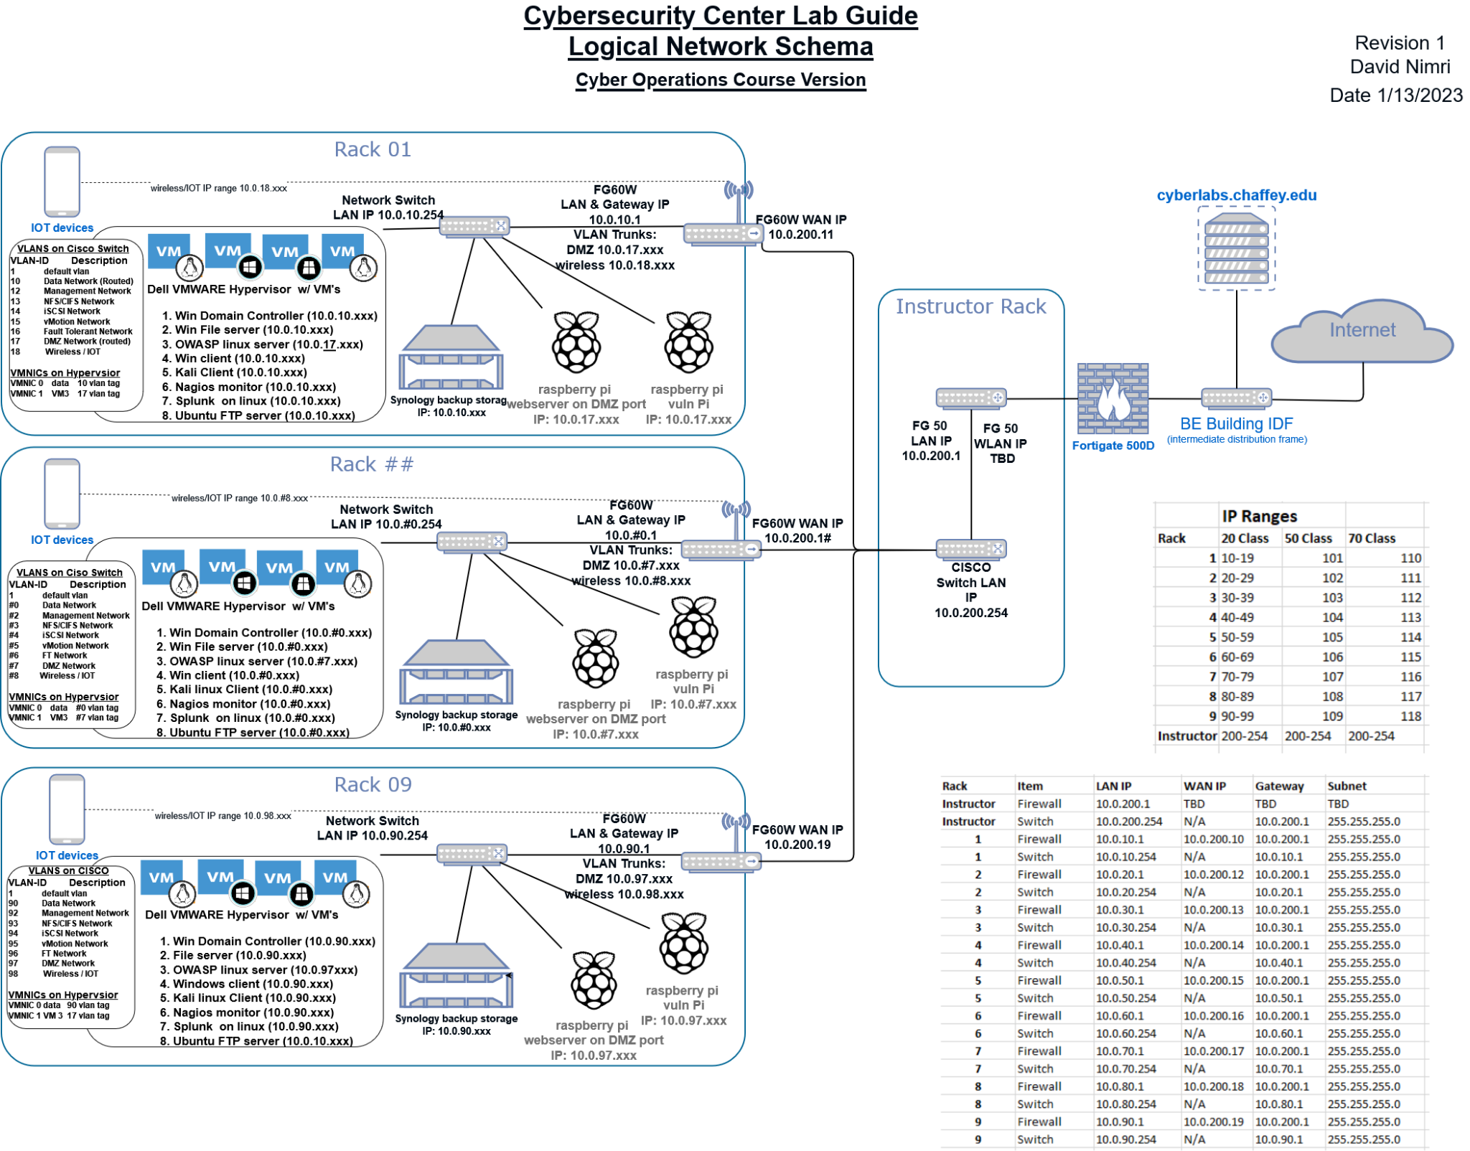

  - Include or reference a complete and accurate listing of all hardware (a reference to the organizational component inventory database is acceptable) and software (system software and application software) components, including make/OEM, model, version, service packs, and person or role responsible for the component.
- Dell PowerEdge R440
- Cisco CBS350-12XT
- Fortinet FortiGate 50E
- Startech SLIDESHELFD
- Tripp-Lite SMART750RM1U
- Tripp-Lite B040-008-19
- Raspberry PI 3 (x2)

  - List all software components installed on the system.
-Raspwn OS 0.12G <https://github.com/alphacharlie/RasPwn>
-FileZilla Linux 3.69.1 <https://filezilla-project.org/download.php>
-ubuntu-mate-22.04.5-desktop-amd64 <https://cdimage.ubuntu.com/ubuntu-mate/releases/jammy/release/>
-FTD3XXLibrary_1.3.0.10 <https://ftdichip.com/drivers/d3xx-drivers/>
-VMware ESXi 8.0 A00 <https://www.dell.com/support/manuals/en-hn/vmware-esxi-8.x/vmware_8.x_icg_pub/dell-customized-vmware-esxi-80-a00-image?guid=guid-3ca2f636-da03-447c-8956-18a3fb283760&lang=en-us>
-Raspberry Pi OS (Legacy) Lite <https://downloads.raspberrypi.com/raspios_oldstable_lite_armhf/images/raspios_oldstable_lite_armhf-2025-05-07/2025-05-06-raspios-bullseye-armhf-lite.img.xz><https://www.raspberrypi.com/software/operating-systems/>

  - Hardware and Software Maintenance and Ownership - Is all hardware and software maintained and owned by the organization?
No. All hardware was provided by the college, and we are only responsible for maintaining it for the semester.

- REQUIREMENTS

(Note: The source of the requirements is NIST Special Publication 800-171, dated December 2016)
Provide a thorough description of how all of the security requirements are being implemented or planned to be implemented. The description for each security requirement contains: 1) the security requirement number and description; 2) how the security requirement is being implemented or planned to be implemented; and 3) any scoping guidance that has been applied (e.g., compensating mitigations(s) in place due to implementation constraints in lieu of the stated requirement). If the requirement is not applicable to the system, provide rationale.
  - Access Control

    - Limit system access to authorized users, processes acting on behalf of authorized users, and devices (including other systems).
X Implemented __ Planned to be Implemented __ Not Applicable
Only admin users were allowed access to the systems, with strict password control and strict access to systems.

    - Separate the duties of individuals to reduce the risk of malevolent activity without collusion.
X Implemented __ Planned to be Implemented __ Not Applicable
Each person has been assigned a role based on what they are most suited for as stated by management. The roles are: Security Analyst, Network Admin, Systems Admin, and Dev/SysOps.

    - Verify and control/limit connections to and use of external systems.
X Implemented __ Planned to be Implemented __ Not Applicable
Ensured that the system is air-gapped and is not able to access outside networks.

  - Audit and Accountability

    - Review and update logged events.
__ Implemented X Planned to be Implemented __ Not Applicable
This is partially completed as the firewall can log events coming out and into the system, but an IDS will be established to monitor traffic and make logs about the internal system.

    - Protect audit information and audit logging tools from unauthorized access, modification, and deletion.
X Implemented __ Planned to be Implemented __ Not Applicable
Made complete backups of systems config files and protected access to information with passwords.

  - Configuration Management

    - Establish and enforce security configuration settings for information technology products employed in organizational systems.
X Implemented __ Planned to be Implemented __ Not Applicable
All systems are protected with password protection and are behind a firewall that is defined with firewall policies to either allow or block traffic based on set criteria.

    - Restrict, disable, or prevent the use of nonessential programs, functions, ports, protocols, and services.
X Implemented __ Planned to be Implemented __ Not Applicable
This is Implemented via the small size of the system. It is very easy to issue policies on workstations that prevent the installation of unauthorized devices, modification of firewall / port controls, and limits on services.

  - Identification and Authentication

    - Enforce a minimum password complexity and change of characters when new passwords are created.
__ Implemented X Planned to be Implemented __ Not Applicable
In the settings within the switch and firewall change the password settings to ensure that there is a minimum requirement for passwords to be 10 characters long and contain a combination of both capital and lowercase letters, numbers, and symbols.

  - Incident Response

    - Establish an operational incident-handling capability for organizational systems that include preparation, detection, analysis, containment, recovery, and user response activities.
X Implemented __ Planned to be Implemented __ Not Applicable
It is already implemented with backups set in motion for recovery in case of incidents occurring. An analysis has been made to determine if it would occur by checking all systems.

    - Test the organizational incident response capability
__ Implemented X Planned to be Implemented __ Not Applicable
It is planned to be implemented due to the possibility of an attacker breaking into individual connections. We will implement an IDS and an on-call plan to have immediate response to breach.

  - Maintenance

    - Perform maintenance on organizational systems.
__ Implemented X Planned to be Implemented __ Not Applicable
It is planned to be implemented with an upgrade to the OS due to the end of life (EOL) and cannot be used with the current OS.

    - Provide controls on the tools, techniques, mechanisms, and personnel used to conduct system maintenance.
__ Implemented X Planned to be Implemented __ Not Applicable
It is planned to be implemented with updates with firmware, using greenbone and nessus to find vulnerabilities and checking the system logs for unusual behavior.

  - Media Protection

    - Control the use of removable media on system components.
X Implemented __ Planned to be Implemented __ Not Applicable
The server is locked when not in use by authorized personnel which prevents unauthorized use of removable media on system components.

  - Risk Assessment

    - Scan for vulnerabilities in organizational systems and applications periodically and when new vulnerabilities affecting those systems and applications are identified.
__ Implemented X Planned to be Implemented __ Not Applicable
It is planned to be implemented with some ideas being nmap that will port scan and detect running services and Nessus is used to scan the whole system performing a vulnerability scan.

    - Remediate vulnerabilities in accordance with risk assessments.
__ Implemented X Planned to be Implemented __ Not Applicable
It is planned to be implemented with solutions given to every risk that was found in the vulnerability scan.

  - Security Assessment

    - Periodically assess the security controls in organizational systems to determine if the controls are effective in their application.
__ Implemented X Planned to be Implemented __ Not Applicable
It is planned to be implemented with Security Control Assessments or (SCAs) which test the security controls and monitoring metrics.

    - Develop and implement plans of action designed to correct deficiencies and reduce or eliminate vulnerabilities in organizational systems.
__ Implemented X Planned to be Implemented __ Not Applicable
Planned to be implemented with a Risk Mitigation plan that will reduce risk and a System Hardening plan to disable unused ports to prevent intrusion.

    - Monitor security controls on an ongoing basis to ensure the continued effectiveness of the controls.
__ Implemented X Planned to be Implemented __ Not Applicable
The system will be added to routine checks of UAC, logs, and users’ privileges, to make sure controls are assigned to the right people and have been removed from those who do not need access to them to perform their routine duties.

    - Develop, document, and periodically update system security plans that describe system boundaries, system environments of operation, how security requirements are implemented, and the relationships with or connections to other systems.
X Implemented __ Planned to be Implemented __ Not Applicable
Due to the scale of the system, manually checking, developing, documenting, and periodic update of system security plans can be done once a month with current team size.

  - System and Communications Protection

    - Monitor, control, and protect communications (i.e., information transmitted or received by organizational systems) at the external boundaries and key internal boundaries of organizational systems.
__ Implemented X Planned to be Implemented __ Not Applicable
This has partial completion as a firewall is in place, but there is no IDS system or system to guard outside of the system. Adding IDS and Malwarebytes are solutions to this problem.

    - Employ architectural designs, software development techniques, and systems engineering principles that promote effective information security within organizational systems.
X Implemented __ Planned to be Implemented __ Not Applicable
The Fortinet FortiGate 50E is the main protection against cyber security attacks, as it blocks unsafe traffic and is configured with the principle of least privilege in mind so that only necessary communications are let through.

    - Deny network communications traffic by default and allow network communications traffic by exception (i.e., deny all, permit by exception).
X Implemented __ Planned to be Implemented __ Not Applicable
This has been implemented via the Fortinet FortiGate 50E firewall. Policies have been enabled to prevent network communication by default and allows network communication only by exception.

  - System and Information Integrity

    - Identify, report, and correct system flaws in a timely manner.
__ Implemented X Planned to be Implemented __ Not Applicable
A ticketing system will be needed to report and correct system flaws in a timely manner. Identification of systems flaws is done with scanning software (Greenbone, Nessus).

    - Monitor system security alerts and advisories and take action in response.
__ Implemented X Planned to be Implemented __ Not Applicable
An IDS needs to be implemented into the system to look for security alerts.

    - Perform periodic scans of organizational systems and real-time scans of files from external sources as files are downloaded, opened, or executed.
__ Implemented X Planned to be Implemented __ Not Applicable
A system is in place to do periodic scans of organization systems (Greenbone and Nessus), but a real time scan system has not been created. Looking at Malwarebytes as a potential solution.

    - Monitor organizational systems, including inbound and outbound communications traffic, to detect attacks and indicators of potential attacks.
X Implemented __ Planned to be Implemented __ Not Applicable
This has been implemented via the Fortinet FortiGate 50 E firewall which has been configured with port filtering, packet filtering, and filtering of inbound and outbound traffic.

- RECORD OF CHANGES

Date | Description | Made By:
5/21/2025 | Initial Report | ATNT

